Chapter 3
Relational Model in DBMS

The Relational Model organizes data using tables (relations) consisting of rows and columns.
- The relational model represents how data is stored and managed in Relational Databases where data is organized into tables, each known as a relation.
- Each row of a table represents an entity or record, and each column represents a particular attribute of that entity.
- The relational model transforms conceptual designs from ER diagrams into implementable structures. These structures are used in relational database systems like Oracle SQL and MySQL.

Example: Consider a relation STUDENT with attributes ROLL_NO, NAME, ADDRESS, PHONE and AGE shown in the table.

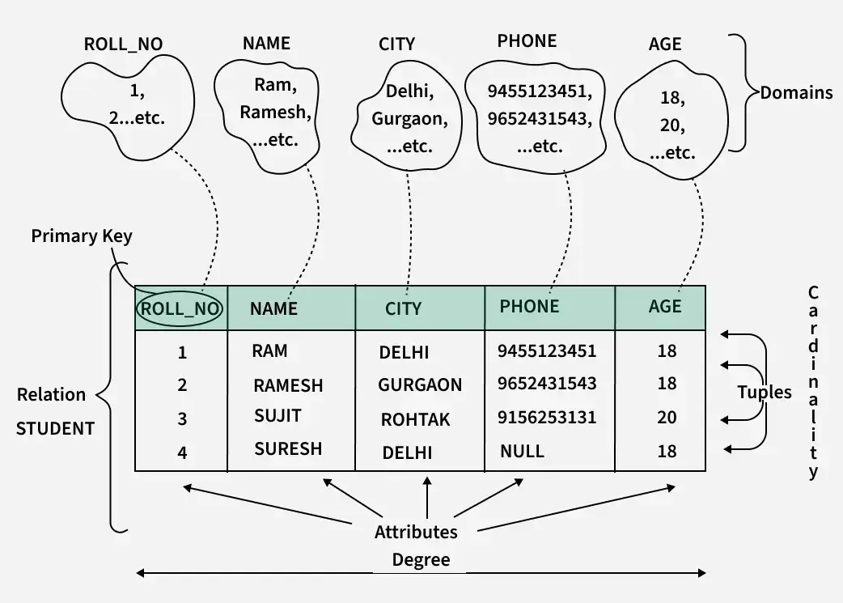

Relational Model

Key Terms in the Relational Model

- Attribute: Attributes are the properties that define an entity. For example, ROLL_NO, NAME, ADDRESS etc.

- Relation Schema: A relation schema defines the structure of the relation and represents the name of the relation with its attributes. For example, STUDENT (ROLL_NO, NAME, ADDRESS, PHONE and AGE) is the relation schema for STUDENT. If a schema has more than 1 relation it is called Relational Schema.

- Tuple: A Tuple represents a row in a relation. Each tuple contains a set of attribute values that describe a particular entity. For example, (1, RAM, DELHI, 9455123451, 18) is a tuple in the STUDENT table.

- Relation Instance: The set of tuples of a relation at a particular instance of time is called a relation instance. It can change whenever there is an insertion, deletion or update in the database.

- Degree: The number of attributes in the relation is known as the degree of the relation. For example, The STUDENT relation has a degree of 5, as it has 5 attributes.

- Cardinality: The number of tuples in a relation is known as cardinality. For example, The STUDENT relation defined above has cardinality 4.

- NULL Values: The value which is not known or unavailable is called a NULL value. It is represented by NULL. For example, PHONE of STUDENT having ROLL_NO 4 is NULL.

Types of Keys in the Relational Model

- Primary Key: A Primary Key uniquely identifies each tuple in a relation. It must contain unique values and cannot have NULL values.

- Candidate Key: A Candidate Key is a set of attributes that can uniquely identify a tuple in a relation.

- Super Key: A Super Key is a set of attributes that can uniquely identify a tuple.

- Foreign Key: A Foreign Key is an attribute in one relation that refers to the primary key of another relation.

- Composite Key: A Composite Key is formed by combining two or more attributes to uniquely identify a tuple.

Characteristics of the Relational Model:

- Data Representation: Data is organized in tables (relations), with rows (tuples) representing records and columns (attributes) representing data fields.

- Atomic Values: Each attribute in a table contains atomic values, meaning no multi-valued or nested data is allowed in a single cell.

- Unique Keys: Every table has a primary key to uniquely identify each record, ensuring no duplicate rows.

- Attribute Domain: Each attribute has a defined domain, specifying the valid data types and constraints for the values it can hold.

- Data Independence: The model ensures logical and physical data independence, allowing changes in the database schema without affecting the application layer.

- Relational Operations: Supports operations like selection, projection, join, union and intersection, enabling powerful data retrieval manipulation.

- Data Consistency: Ensures data consistency through constraints, reducing redundancy and anomalies.
- Set-Based Representation: Tables in the relational model are treated sets and operations follow mathematical set theory principles.

Constraints in Relational Model

While designing the Relational Model, we define some conditions which must hold for data present in the database are called Constraints. These constraints are checked before performing any operation (insertion, deletion and updating) in the database. If there is a violation of any of the constraints, the operation will fail.

- Domain Constraints

Domain Constraints ensure that the value of each attribute A in a tuple must be an atomic value derived from its specified domain, dom(A). Domains are defined by the data types associated with the attributes. Common data types include:

- Numeric types: Includes integers (short, regular and long) for whole numbers and real numbers (float, double-precision) for decimal values, allowing precise calculations.

- Character types: Consists of fixed-length (CHAR) and variable-length (VARCHAR, TEXT) strings for storing text data of various sizes.

- Boolean values: Stores true or false values, often used for flags or conditional checks in databases.

- Specialized types: Includes types for date (DATE), time (TIME), timestamp (TIMESTAMP) and money (MONEY), used for precise handling of time-related and financial data.

- Key Integrity

Every relation in the database should have at least one set of attributes that defines a tuple uniquely. Those set of attributes is called keys. e.g.; ROLL_NO in STUDENT is key. No two students can have the same roll number. So a key has two properties:
- It should be unique for all tuples.
- It can’t have NULL values.

- Referential Integrity Constraints

When one attribute of a relation can only take values from another attribute of the same relation or any other relation, it is called referential integrity. Let us suppose we have 2 relations

Table: STUDENT

ROLL_NO | NAME | ADDRESS | PHONE | AGE | BRANCH_CODE
1 | RAM | DELHI | 9455123451 | 18 | CS
2 | RAMESH | GURGAON | 9652431543 | 18 | CS
3 | SUJIT | ROHTAK | 9156253131 | 20 | ECE
4 | SURESH | DELHI |  | 18 | IT

Table: BRANCH
BRANCH_CODE | BRANCH_NAME
CS | COMPUTER SCIENCE
IT | INFORMATION TECHNOLOGY
ECE | ELECTRONICS AND COMMUNICATION ENGINEERING
CV | CIVIL ENGINEERING

Explanation: BRANCH_CODE of STUDENT can only take the values which are present in BRANCH_CODE of BRANCH which is called referential integrity constraint. The relation which is referencing another relation is called REFERENCING RELATION (STUDENT in this case) and the relation to which other relations refer is called REFERENCED RELATION (BRANCH in this case).

Anomalies in the Relational Model
An anomaly is an irregularity or something which deviates from the expected or normal state. When designing databases, we identify three types of anomalies: Insert, Update, and Delete.

- Insertion Anomaly in Referencing Relation: We can’t insert a row in REFERENCING RELATION if referencing attribute’s value is not present in the referenced attribute value. e.g.; Insertion of a student with BRANCH_CODE ‘ME’ in STUDENT relation will result in an error because ‘ME’ is not present in BRANCH_CODE of BRANCH.

- Deletion/ Updation Anomaly in Referenced Relation: We can’t delete or update a row from REFERENCED RELATION if the value of REFERENCED ATTRIBUTE is used in the value of REFERENCING ATTRIBUTE. For example, If we try to delete a tuple from BRANCH having BRANCH_CODE ‘CS’, it will result in an error because ‘CS’ is referenced by BRANCH_CODE of STUDENT, but if we try to delete the row from BRANCH with BRANCH_CODE CV, it will be deleted as the value is not been used by referencing relation.

Advantages of the Relational Model
- Simple model: Relational Model is simple and easy to use in comparison to other languages.
- Flexible: Relational Model is more flexible than any other relational model present.
- Secure: Relational Model is more secure than any other relational model.
- Data Accuracy: Data is more accurate in the relational data model.
- Data Integrity: The integrity of the data is maintained in the relational model.
- Operations can be Applied Easily: It is better to perform operations in the relational model.

Disadvantages of the Relational Model
- Performance: The relational model can experience performance issues with very large databases.
- Complexity for Complex Data: The model struggles with hierarchical or complex data relationships, which might be better handled with other models like the Graph or Document model.
- Normalization Overhead: Extensive use of normalization can result in complex queries and slower performance.

  - Constraints in RDBMS:
    - Primary Key:

Definition
A Primary Key is a special column (or combination of columns) in a database table that uniquely identifies each record (row). It is the foundation of relational database design because it provides a way to distinguish one row from another.

Key Characteristics
- Uniqueness
  - Each value in the primary key column(s) must be unique.
  - No two rows can share the same primary key value.
- Not Null
  - Primary key columns cannot contain NULL values.
  - This ensures that every row has a valid identifier.
- One per Table
  - A table can have only one primary key.
  - However, that primary key may consist of multiple columns (called a composite primary key).
- Index Creation
  - Most database systems automatically create a unique index for the primary key to speed up searches and joins.
- Relationship Foundation
  - Primary keys are often used in other tables as foreign keys to establish relationships between tables.

Purpose / Importance
- Ensures entity integrity: no duplicate rows, every row can be uniquely referenced.
- Forms the backbone for joins and referential integrity with other tables.
- Helps improve query performance because of automatic indexing.

Examples in Real Life
- Student Table → student_id can be the primary key.
- Employee Table → employee_id can be the primary key.
- Library System → a composite primary key might be (book_id, member_id) for issued books.

Difference from Other Constraints
- Primary Key vs. Unique Key → Primary key cannot be NULL and only one per table, but you can have multiple unique keys.
- Primary Key vs. Foreign Key → Primary key uniquely identifies records in one table; foreign key refers to that primary key from another table to maintain a relationship.
In short:
A primary key = “the unique identifier” of a table.
It enforces uniqueness + non-nullability to ensure each record is distinct and easily referenced.
    - UNIQUE KEY:

Definition
A UNIQUE constraint in SQL ensures that all values in a column (or a combination of columns) are distinct — no two rows can have the same value in that column or column set.
It is used to maintain data integrity by preventing duplicate values where they are not allowed.

Key Characteristics
- Uniqueness
  - Every value in a UNIQUE column must be different.
  - This guarantees no duplicates.
- NULL Allowed (with Caution)
  - Unlike a Primary Key, a UNIQUE column can contain NULL values (but usually only one NULL per column depending on the database engine).
  - This is because NULL is treated as “unknown,” and two NULLs are not considered equal in SQL logic.
- Multiple UNIQUE Constraints
  - A table can have more than one UNIQUE constraint on different columns.
  - This allows you to enforce uniqueness for several different fields.
- Composite UNIQUE
  - You can define a UNIQUE constraint on a combination of columns, ensuring that the combination is unique across all rows (even if individual column values repeat).
- Index Creation
  - When you apply a UNIQUE constraint, the database automatically creates a unique index to speed up lookups.

Purpose / Importance
- Ensures data consistency (no duplicate email IDs, no duplicate mobile numbers, etc.).
- Allows you to maintain uniqueness on one or more columns without making them the Primary Key.
- Often used alongside a Primary Key for additional uniqueness checks.

Examples in Real Life
- In a User Table, email might be marked UNIQUE so no two users can have the same email address.
- In an Employee Table, phone_number might be UNIQUE to prevent duplicate phone numbers.
- In a Registration Table, you might set a UNIQUE constraint on (student_id, course_id) so the same student can’t register for the same course twice.

Difference from Primary Key
Feature | Primary Key | Unique Key / Constraint
Null allowed | Not allowed (cannot be NULL) | Allowed (usually one NULL per column)
How many per table | Only one Primary Key | Multiple Unique constraints allowed
Purpose | Main identifier for each row | Additional uniqueness requirement

In short:
A UNIQUE constraint prevents duplicate values in a column or set of columns but, unlike a Primary Key, it can allow NULL and you can have multiple UNIQUE constraints in a table.
    - FOREIGN KEY

Definition
A FOREIGN KEY is a column (or set of columns) in one table that refers to the Primary Key (or a UNIQUE key) of another table.
It establishes a relationship between two tables and enforces referential integrity — meaning you cannot insert a value in the foreign key column that does not exist in the parent table.

Key Characteristics
- Reference to Another Table
  - A foreign key always points to a column in another table (the “parent” or “referenced” table).
  - That referenced column must be either a Primary Key or a Unique Key.
- Maintains Referential Integrity
  - Ensures that values in the child table’s foreign key column(s) match existing values in the parent table, or are NULL (if allowed).
  - Prevents orphan records.
- Multiple Foreign Keys
  - A table can have more than one foreign key, each referencing different parent tables.
- Cascading Actions
  - When you define a foreign key, you can specify what happens if the parent data changes or is deleted:
    - ON DELETE CASCADE → Delete child rows automatically when the parent row is deleted.
    - ON UPDATE CASCADE → Update child rows automatically when the parent’s key changes.
    - Other options: SET NULL, NO ACTION, RESTRICT.
- Not a Unique Identifier
  - A foreign key itself does not have to be unique in the child table. Many rows can reference the same parent row.

Purpose / Importance
- Establishes logical relationships between tables in a relational database.
- Ensures data consistency across related tables (no invalid references).
- Supports relational operations like joins naturally.

Examples in Real Life
- Students & Departments
  - Departments(dept_id) is the primary key.
  - Students(dept_id) is the foreign key referring to Departments.dept_id.
  - This ensures that each student belongs to a valid department.
- Orders & Customers
  - Customers(customer_id) is the primary key.
  - Orders(customer_id) is the foreign key referring to Customers.customer_id.
  - This ensures every order is linked to an existing customer.

Difference from Primary / Unique Key
Feature | Primary Key | Unique Key | Foreign Key
Identifies | Row uniquely in same table | Enforces uniqueness in same table | Establishes link to another table
Null allowed | Not allowed | Allowed (usually one) | Allowed (if specified)
How many per table | Only one Primary Key | Multiple Unique Keys allowed | Multiple Foreign Keys allowed
Purpose | Main identifier | Extra uniqueness | Maintain referential integrity
In short:
A FOREIGN KEY links one table to another by referencing its primary key (or unique key), ensuring that data in both tables stays consistent and valid.
    - Check Constraints:

Definition
A CHECK constraint in SQL is used to limit the values that can be placed in a column.
It enforces a logical condition on data being inserted or updated so that only values satisfying the condition are allowed.

Key Characteristics
- Validation Rule
  - You specify a condition (for example, age >= 18).
  - When you insert or update data, the database checks the condition; if it fails, the operation is rejected.
- Column-level or Table-level
  - You can define it on a single column (applies only to that column).
  - Or as a table-level constraint using multiple columns in the condition.
- Multiple CHECK Constraints
  - A table can have multiple CHECK constraints. Each is evaluated separately.
- Ensures Data Integrity
  - Prevents invalid data (like negative salary, invalid date ranges, etc.) from entering the table.
- MySQL Version Note
  - Native CHECK constraint enforcement is supported from MySQL 8.0.16 onwards.
  - In older MySQL versions, the syntax is accepted but ignored (you’d use triggers instead).

Purpose / Importance
- Provides a simple way to validate business rules at the database level.
- Ensures data quality without needing application-level checks.
- Reduces errors and inconsistencies in stored data.

Examples in Real Life
- Age Restriction:
Only allow ages 18 and above:
- CHECK (age >= 18)
- Salary Non-Negative:
Prevent negative salaries:
- CHECK (salary >= 0)
- Date Logic:
End date must be greater than start date:
- CHECK (end_date > start_date)

Difference from Other Constraints
Feature | Primary Key | Unique Key | Foreign Key | CHECK Constraint
Purpose | Identify rows uniquely | Prevent duplicates | Link tables & enforce referential integrity | Validate a condition on data values
Null Allowed | No | Yes (one NULL) | Yes (if allowed) | Yes (if condition allows)
Where It Applies | Column(s) in a table | Column(s) in a table | Column(s) in a child table referencing parent | Column(s) with condition

In short:
A CHECK constraint lets you specify a rule for acceptable values in a column (or combination of columns). If the rule is violated during INSERT or UPDATE, the database throws an error and rejects the operation.
- IN, NOT IN, BETWEEN..AND, LIKE
Table Data
EmpID | Name | Department | Salary
1 | Alice | HR | 40000
2 | Bob | Finance | 55000
3 | Charlie | IT | 35000
4 | David | Sales | 30000
5 | Eve | Finance | 47000
6 | Anita | IT | 25000
7 | John | Marketing | 60000

2️⃣ Using IN
SELECT * FROM Employees
WHERE Department IN ('HR', 'IT');
✅ Explanation:
This retrieves only rows where Department is either HR or IT.
Result:
EmpID | Name | Department | Salary
1 | Alice | HR | 40000
3 | Charlie | IT | 35000
6 | Anita | IT | 25000

3️⃣ Using NOT IN
SELECT * FROM Employees
WHERE Department NOT IN ('Finance', 'Sales');
✅ Explanation:
This retrieves all rows where Department is not Finance or Sales.
Result:
EmpID | Name | Department | Salary
1 | Alice | HR | 40000
3 | Charlie | IT | 35000
6 | Anita | IT | 25000
7 | John | Marketing | 60000

4️⃣ Using BETWEEN … AND …
SELECT * FROM Employees
WHERE Salary BETWEEN 30000 AND 50000;
✅ Explanation:
It returns rows where Salary is ≥30000 and ≤50000.
Result:
EmpID | Name | Department | Salary
1 | Alice | HR | 40000
3 | Charlie | IT | 35000
4 | David | Sales | 30000
5 | Eve | Finance | 47000

5️⃣ Using LIKE
Examples:
-- Names starting with 'A'
SELECT * FROM Employees
WHERE Name LIKE 'A%';
✅ Explanation:
A% means names starting with A and followed by any number of characters.
Result: Alice, Anita

-- Names ending with 'e'
SELECT * FROM Employees
WHERE Name LIKE '%e';
✅ Explanation:
%e means names ending with e.
Result: Alice, Eve, Charlie

-- Second letter is 'o'
SELECT * FROM Employees
WHERE Name LIKE '_o%';
✅ Explanation:
_o% means any single character followed by o, then any number of characters.
Result: Bob, John

📝 Quick Summary Table
Operator | What it does | Example
IN | Matches any value in a list | WHERE Department IN ('HR','IT')
NOT IN | Excludes values in a list | WHERE Department NOT IN ('Finance')
BETWEEN | Matches a range (inclusive) | WHERE Salary BETWEEN 30000 AND 50000
LIKE | Pattern matching in text | WHERE Name LIKE 'A%'
co
Would you like me to also show how to combine these (e.g., IN + BETWEEN + LIKE in one query) for advanced practice?

SQL Functions (Aggregate and Scalar Functions)

SQL Functions are built-in programs that are used to perform different operations on the database.

There are two types of functions in SQL:
- Aggregate Functions
- Scalar Functions

SQL Aggregate Functions

SQL Aggregate Functions operate on a data group and return a singular output. They are mostly used with the GROUP BY clause to summarize data.

Some common Aggregate functions with Syntax and description are shown in the table below.
Aggregate Function | Description | Syntax
AVG() | Calculates the average value | SELECT AVG(column_name) FROM table_name;
COUNT() | Counts the number of rows | SELECT COUNT(column_name) FROM table_name
FIRST() | Returns the first value in an ordered set of values | SELECT FIRST(column_name) FROM table_name;
LAST() | Returns the last value in an ordered set of values | SELECT LAST(column_name) FROM table_name;
MAX() | Retrieves the maximum value from a column | SELECT MAX(column_name) FROM table_name;
MIN() | Retrieves the minimum value from a column | SELECT MIN(column_name) FROM table_name;
SUM() | Calculates the total sum of values in a numeric column | SELECT SUM(column_name) FROM table_name;

SQL Scalar functions
SQL Scalar Functions are built-in functions that operate on a single value and return a single value.
Scalar functions in SQL helps in efficient data manipulation and simplification of complex calculations in SQL queries.
Scalar function | Description | Syntax
UCASE() | Converts a string to uppercase | SELECT UCASE(column_name) FROM table_name;
LCASE() | Converts a string to lowercase | SELECT LCASE(column_name) FROM table_name;
MID() | Extracts a substring from a string | SELECT MID(column_name, start, length) FROM table_name;
LEN() | Returns the length of a string | SELECT LEN(column_name) FROM table_name;
ROUND() | Rounds a number to a specified number of decimals | SELECT ROUND(column_name, decimals) FROM table_name;
NOW() | Returns the current date and time | SELECT NOW();
FORMAT() | Formats a value with the specified format | SELECT FORMAT(column_name, format) FROM table_name;

SQL Functions Examples
Let's look at some examples of SQL Functions. We will cover examples of SQL aggregate functions and scalar functions.
We will perform queries on the given SQL table:

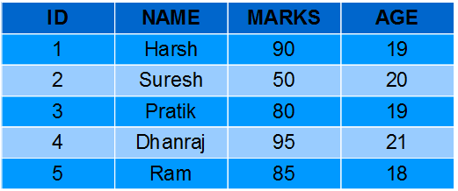

Aggregate Functions Examples

Let's look at the examples of each aggregate function in SQL.
AVG() Function Example
Computing average marks of students.
Query:
SELECT AVG(MARKS) AS AvgMarks FROM Students;
Output:
AvgMarks
80
COUNT() Function Example
Computing total number of students.
Query:
SELECT COUNT(*) AS NumStudents FROM Students;
Output:
NumStudents
5
FIRST() Function Example
Fetching marks of first student from the Students table.
Query:
SELECT FIRST(MARKS) AS MarksFirst FROM Students;
Output:
MarksFirst
90
LAST() Function Example
Fetching marks of last student from the Students table.
Query:
SELECT LAST(MARKS) AS MarksLast FROM Students;
Output:
MarksLast
85
MAX() Function Example
Fetching maximum marks among students from the Students table.
Query:
SELECT MAX(MARKS) AS MaxMarks FROM Students;
Output:
MaxMarks
95
MIN() Function Example
Fetching minimum marks among students from the Students table.
Query:
SELECT MIN(MARKS) AS MinMarks FROM Students;
Output:
MinMarks
50
SUM() Function Example
Fetching summation of total marks among students from the Students table.
Query:
SELECT SUM(MARKS) AS TotalMarks FROM Students;
Output:
TotalMarks
400

Scalar Functions Examples
Let's look at some examples of each Scalar Function in SQL.
UCASE() Function Example
Converting names of students from the table Students to uppercase.
Query:
SELECT UCASE(NAME) FROM Students;
Output:
NAME
HARSH
SURESH
PRATIK
DHANRAJ
RAM
LCASE() Function Example
Converting names of students from the table Students to lowercase.
Query:
SELECT LCASE(NAME) FROM Students;
Output:
NAME
harsh
suresh
pratik
dhanraj
ram
MID() Function Example
Fetching first four characters of names of students from the Students table.
Query:
SELECT MID(NAME,1,4) FROM Students;
Output:
NAME
HARS
SURE
PRAT
DHAN
RAM
LEN() Function Example
Fetching length of names of students from Students table.
Query:
SELECT LENGTH(NAME) FROM Students;
Output:
NAME
5
6
6
7
3
ROUND() Function Example
Fetching maximum marks among students from the Students table.
Query:
SELECT ROUND(MARKS,0) FROM Students;
Output:
MARKS
90
50
80
95
85
NOW() Function Example
Fetching current system time.
Query:
SELECT NAME, NOW() AS DateTime FROM Students;
Output:
NAME | DateTime
HARSH | 1/13/2017 1:30:11 PM
SURESH | 1/13/2017 1:30:11 PM
PRATIK | 1/13/2017 1:30:11 PM
DHANRAJ | 1/13/2017 1:30:11 PM
RAM | 1/13/2017 1:30:11 PM
FORMAT() Function Example
Formatting current date as 'YYYY-MM-DD'.
Query:
SELECT NAME, FORMAT(Now(),'YYYY-MM-DD') AS Date FROM Students;
Output:
NAME | Date
HARSH | 2017-01-13
SURESH | 2017-01-13
PRATIK | 2017-01-13
DHANRAJ | 2017-01-13
RAM | 2017-01-13

Important Points About SQL Functions
- SQL functions are built-in programs that are used to manipulate data in various ways.
- There are different types of SQL functions - Aggregate functions and Scalar functions.
- Aggregate functions perform calculations on a group of values and return a single value. Example SUM, AVG, COUNT.
- Scalar functions operate on a single value and return a single value. Example UPPER, LOWER, SUBSTRING.
- SQL functions can be used in different SQL statements, such as SELECT, WHERE, GROUP BY, and ORDER BY, to improve data processing and analysis.

